Microsoft’s Cortana

A Project Report Submitted
for

Information Technology
By

Sumit Basera

Under the guidance of
Mr. Praveen Kumar Joshi



EVER GREEN SENIOR SECONDARY SCHOOL
(GOVERNED BY EDUCATIONAL WELFARE SOCIETY)
TULARAMPUR - 263139, DISTRICT-NAINITAL
UTTARAKHAND, INDIA

OCTOBER, 2021

CERTIFICATE

This is to certify that the project entitled “Microsoft’s Cortana” being submitted to Evergeen Senior Secondary School, Haldwani for the project work of INFORMATION TECHNOLOGY is a record of the work carried by MR. PRAVEEN KUMAR JOSHI under my guidance and supervision.

Date : 2021-10-08 Supervisor
MR. PRAVEENJOSHI
TGT Computer
Ever Green Sr. Sec. School, Haldwani
Forwarded By:
MR. M.S. PARWAL
Principal
Ever Green Sr. Sec. School, Haldwani

ABSTRACT
Voice assistants are software agents that can interpret human speech and respond via synthesized voices. Apple's Siri, Amazon's Alexa, Microsoft's Cortana, and Google's Assistant are the most popular voice assistants and are embedded in smartphones or dedicated home speakers. Users can ask their assistants questions, control home automation devices and media playback via voice, and manage other basic tasks such as email, to-do lists, and calendars with verbal commands. This column will explore the basic workings and common features of today's voice assistants. It will also discuss some of the privacy and security issues inherent to voice assistants and some potential future uses for these devices. As voice assistants become more widely used, librarians will want to be familiar with their operation and perhaps consider them as a means to deliver library services and materials.
Before we know about its feature let’s know about Cortana basic
We should cover a bit of background. Cortana used to be integrated in the Windows search box: Whether you performed a search by speaking or typing, the results were delivered in the Cortana pane. But that’s changed over time. First, Microsoft separated Cortana from the Windows search box. And then Microsoft went ever further and turned Cortana into its own app that works like any other Windows 10 app, including running in a resizable window that can be moved around the screen.
That’s the way it works now. So the only way to use Cortana is to run the app. You can start it by clicking the Cortana icon in the taskbar just to the right of the search box, pressing the Windows key + C, or saying “Cortana.”
Once you start the app, to perform a Cortana search, you say “Hey Cortana” and speak your search, or click the Cortana icon to the right of the search box and speak, or press the Windows key + C and speak or type.
When you ask Cortana a straightforward question or issue a straightforward command, Cortana displays the result onscreen and reads it to you. However, if you ask a more complicated question that requires a display of web links, Cortana will show the links in the Edge browser.
How to open it

Activate "Cortana" mode
Open Cortana, select Settings , and then under Talk to Cortana switch the wake word toggle to On.

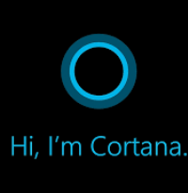

Now the question stand what Cortana can do ? what is its feature?
- Manage your calendar and keep your schedule up to date.
- Join a meeting in Microsoft Teams or find out who your next meeting is with.
- Create and manage lists.
- Set reminders and alarms.
- Find facts, definitions, and info.
- Open apps on your computer.
Let’s know it feature briefly.
There some useful feature of Cortana
- Set Reminders for Times, Places, and People
Cortana has a powerful built-in reminder feature, but there’s more you can do with these reminders than simply getting a reminder at a specific time.Use the Reminders icon or say “Remind me” to get started. You can create a reminder and have Cortana remind you about something at a specific time, when you get to a specific location, or when you talk to a specific person. You can also just say something like “Remind me to take my pill at 8pm” or “Remind me to buy milk when I get to [name of a store]” to instantly create a reminder.

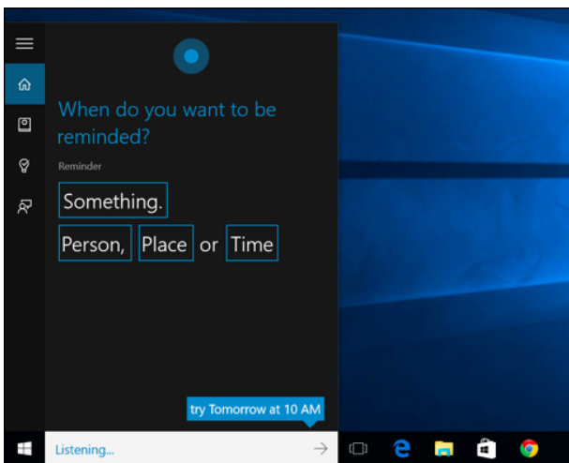

- Identify a Song
Like Siri, Google Now, and dedicated apps like Shazam, Cortana can listen to a song playing near you and identify it. Say “What is this song?” and Cortana will use your microphone to listen to the music and match it to a specific song. Obviously, this works well with recorded music but won’t necessarily work with live music.
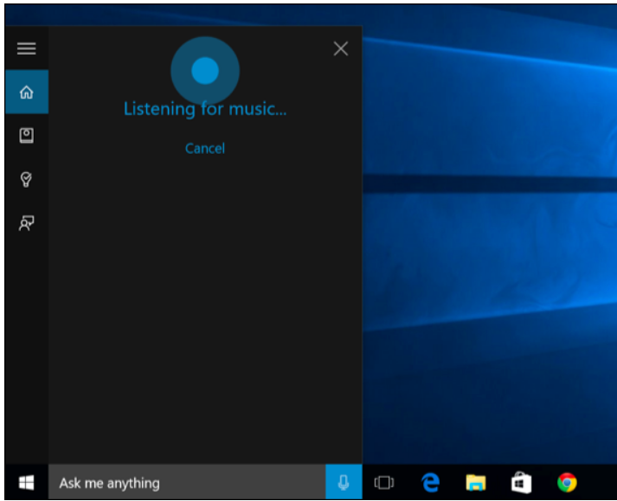

- Find Facts
Cortana uses Bing to provide direct answers to common questions. This is similar to Google’s Knowledge Graph. For example, you can ask questions like “What is the tallest building in the world?” or “Who is the president of the United States?” to get an immediate answer.
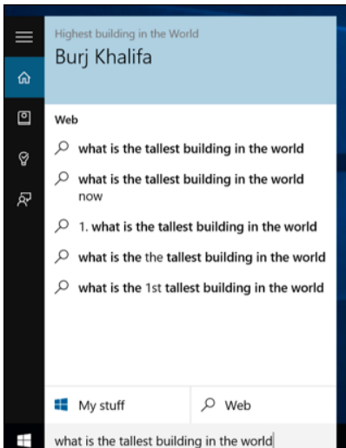
- Launch Programs
Cortana can launch programs for you. Just say “Launch [program name].” If you have the “Hey Cortana” voice shortcut enabled, this means you can just say “Hey Cortana, launch Google Chrome” to your PC and it will automatically open that ap
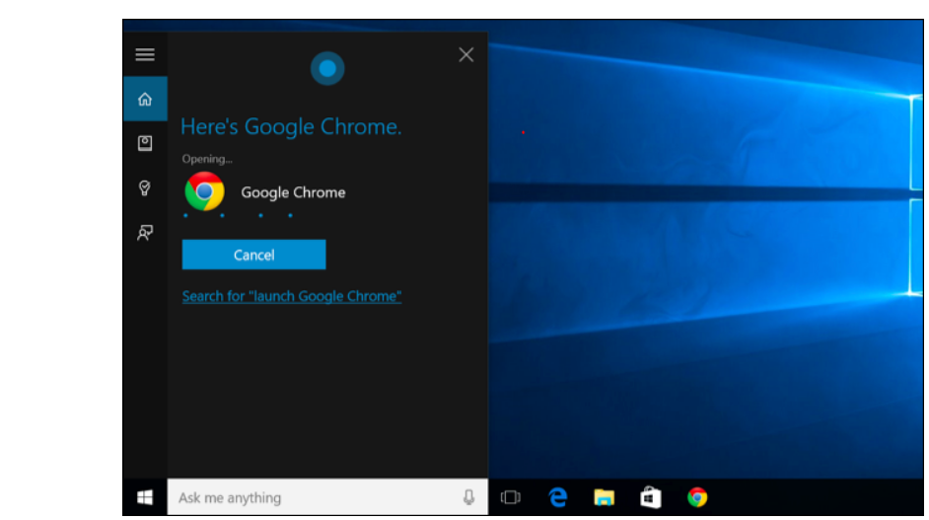
- Set Alarms
Cortana also supports alarms, not just reminders. Ask Cortana to “set alarm for [time]” and it will create an alarm for you. The alarm here is saved in the Alarms & Clock app, where you can manage your alarms.

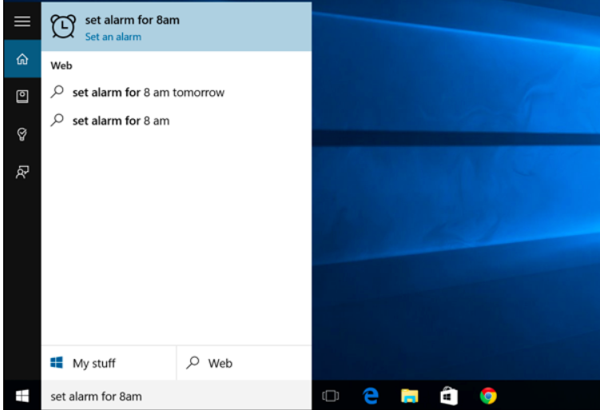
- Get Directions
Cortana can respond with directions, too. Ask for “directions to [location]” and Cortana will open the included Windows 10 Maps app with directions to your location of choice.
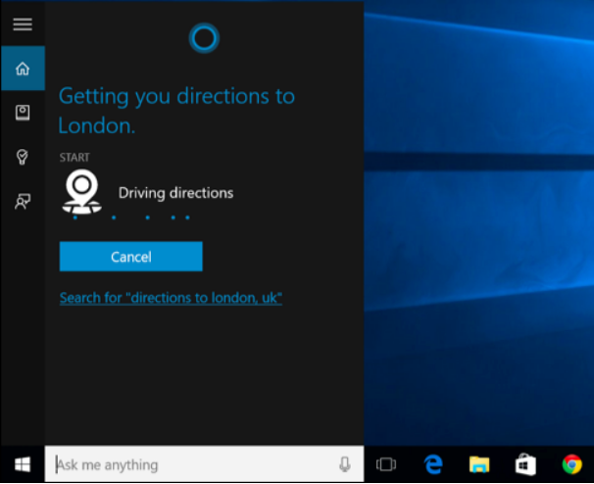
- Send Email
Cortana can send emails using the built-in Mail app and the accounts you’ve configured there. Just say “send email” to get started, or say something more specific like “Send email to Pete” if that’s a person in your contacts.
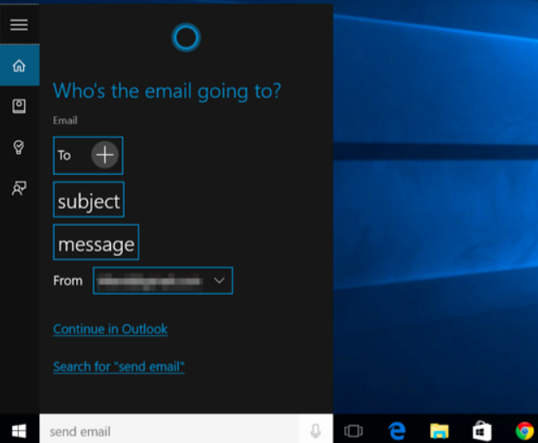

Create Calendar Events

Cortana can also create calendar events. Just say something like “add meeting at Thursday 2pm to calendar” and Cortana will automatically fill in the information you’ve provided. You can also just start with “add meeting” and Cortana will ask for more details.

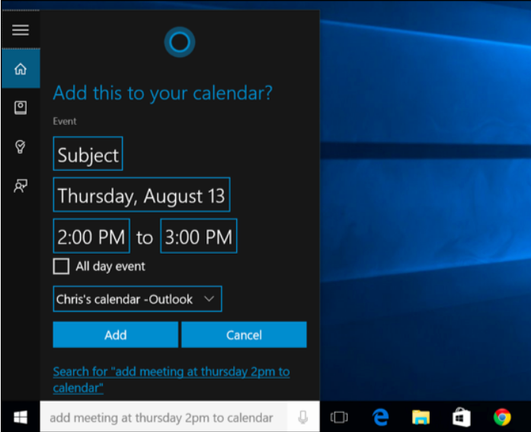
- Just Chat
Like Siri, Cortana can “chat” about things and respond to silly questions with snappy answers. Ask Cortana a question like “Where’s Clippy?” or even give an instruction like “Tell me a story,” “Tell me a joke,” “Sing me a song,” or “Surprise me!”

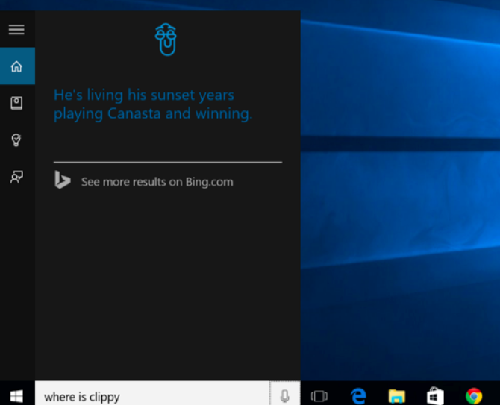

- Track Flights and Packages
Cortana can track flights using the flight number and packages using their tracking numbers. Just enter a flight or package tracking number into the Cortana search box — you could just copy-and-paste it — to view the current status
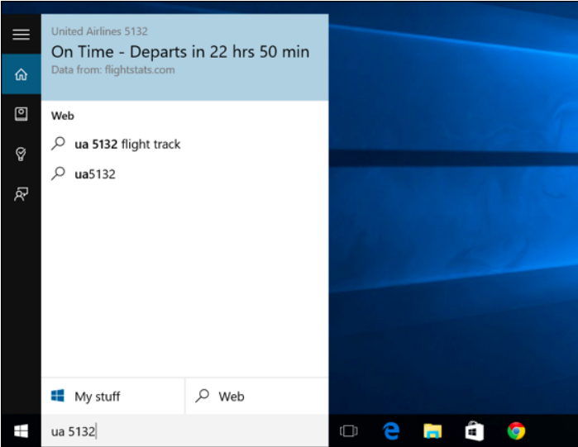
- Perform Calculations and Conversions
Cortana can perform quick calculations, too. Remember that you can type into the Cortana search box, too — you don’t have to speak long numbers.You can either ask Cortana for the answer to a math calculation like “324234 * 34234” or enter a unit conversion like “55 uk pounds to usd”. This works for currencies as well as other types of units.
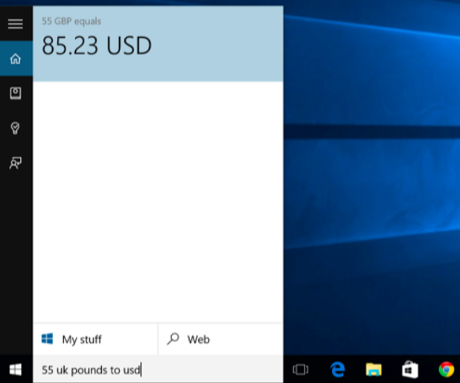
- Check the Weather
Use Cortana to quickly check the weather in different locations. “Weather” will show you the weather at your current location, while “weather in [location]” will show you the weather in another city.
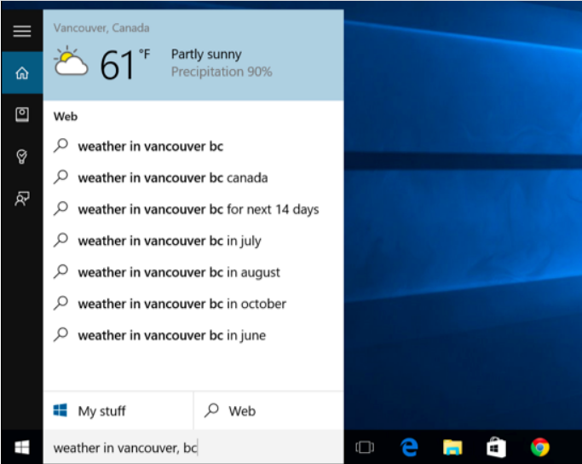
Microsoft’s Cortana may be beter in future. Nowadays it is also smart but, we hope that it will be more technical and able to do more operation. And it very good app or software of windows. I like it personally. Hopefully In future we can see more software of Microsoft like Cortana. It is able to do anything we want, but we can only acess it on window 10.

ACKNOWLEDGEMENT
I would like to thank my teacher (MR. Praveen Joshi) who gave me this opportunity to work on this project. I got to learn a lot from this project about (Microsoft’s Cortana and its function and important uses). I would also like to thank our school principal (Mr. M.S. Parwal,).
At last, I would like to extend my heartfelt thanks to my parents because without their help this project would not have been successful. Finally, I would like to thank my dear friends who have been with me all the time

(Sumit Basera)

TABLE OF CONTENTS

Chapter | Topic | Page No.
 | CERTIFICATE | 2
 | ACKNOWLEDGEMENT | 10
 | FEATURES | 4,5,6,7,8,9
 | ABSTRACT | 3
1. | INTRODUCTION | 3
1.1 | SUMMARY AND FUTURE WORK | 10

